CSCD350 Assignment 8

Team: Fast Fire File Flyers(4F) Lead: Brandon Fowler

Members: James White, Zach Lontz, Daniil Borisov, Brandon Fowler

All stories for iteration 1 were completed and accepted:

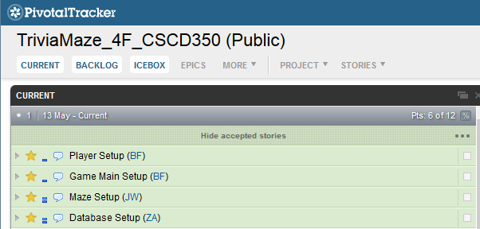

Made a folder called iteration 1 on GitHub, and working code for iteration 1 has been synced:

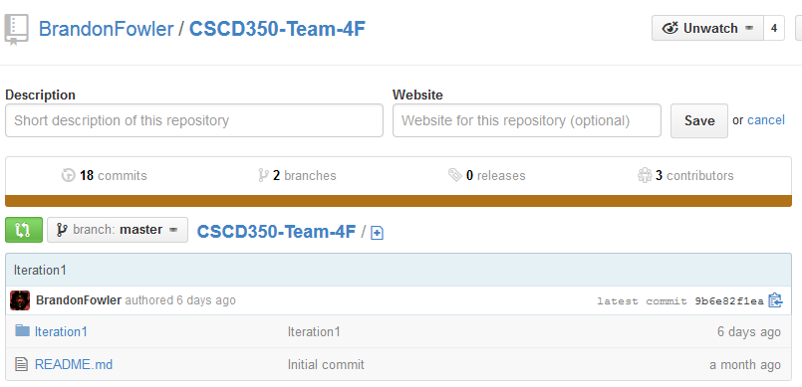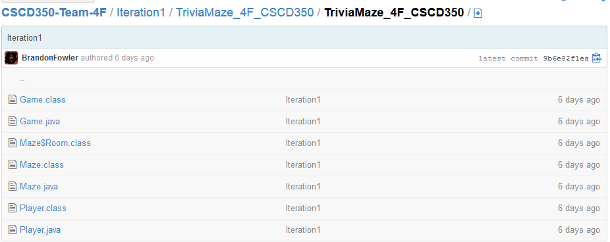

So far the project has base functionality on the command line. The maze is printed to the screen. The user is able to move, and see his new position. Maze bounds are enforced. Doors are locked or opened based on a yes or no question(no database plugged in yet). User can win the game by reaching the end.

